**EET 1140**

1. **LAB NUMBER:** 1

2. **TITLE: Resistance, Voltage and Current Measurements, and Ohm’s Law.**

**3. OBJECTIVES:**

After completing this lab, the student will be able to:

a) measure resistance, voltage and current in a DC circuit.

b) confirm Ohm’s Law from measured data.

**4. EQUIPMENT:**

DC Power Supply: Uni PS-2303

Digital Multimeter: RIGOL DM 3058E

Experimenter board (C.A.D.E.T.) or a Breadboard

**5. COMPONENTS:**

1 - 510 Ω ½ watt 5% Resistor

1 - 1000 Ω ½ watt 5% Resistor

1 - 2000 Ω ½ watt 5% Resistor

1 - 4700 Ω ½ watt 5% Resistor

1 - 10000 Ω ½ watt 5% Resistor

**6. TEXT REFERENCE:**

Circuit Analysis: Theory and Practice (5th Edition): A.H. Robbins and W.C. Miller

Section 2.6: Measuring Voltage and Current

Section 3.6: Color Coding of Resistors

Section 3.7: Measuring Resistance – the Ohmmeter

Section 4.1: Ohm’s Law

**7. PRE-LAB ASSIGMENT:**

a) Determine the Color Codes for the Resistors used in this lab and calculate the upper and lower values for the 5% tolerance.

Table 1:

|  |  |  |  |  |  |
| --- | --- | --- | --- | --- | --- |
| Resistor | Band 1 | Band 2 | Band 3  (Multiplier) | Band 4  (Tolerance) | Lower – Upper Values (ohm) |
| R1: 510Ω | Green | Brown | Brown | Gold | 484.500 – 535.500 |
| R2: 1000Ω | Brown | Black | Red | Gold | 950.000 -1050.000 |
| R3: 2000Ω | Red | Black | Red | Gold | 1900.000 – 2100.000 |
| R4: 4700Ω | Yellow | Purple | Red | Gold | 4465.000 – 4935.000 |
| R5: 10,000Ω | Brown | Black | Orange | Gold | 9500.000 – 10500.000 |

b) Using Ohm’s law (I=E/R) and a source voltage of ***5 volts***, calculate the current through each resistor:

Table 2:

|  |  |
| --- | --- |
| Resistor | Current (mA) |
| R1 | 9.804 |
| R2 | 5.000 |
| R3 | 2.500 |
| R4 | 1.064 |
| R5 | 0.500 |

c) Using Ohm’s law (E=RI) with ***R = 2KΩ***, calculate the expected source voltage E as the source current changes:

Table 3:

|  |  |
| --- | --- |
| Current (mA) | Voltage (V) |
| 1 | 2.000 |
| 2 | 4.000 |
| 3 | 6.000 |
| 4 | 8.000 |
| 5 | 10.000 |

**8. MEASUREMENTS:**

a) Measuring Resistance:

Set the DMM to measuring Resistance (Ω). Measure the resistance of all resistors in Table 1 and record the results in Table 4

Table 4:

|  |  |
| --- | --- |
| Resistor | Measured Resistance (Ω) |
| R1 | 503.23 |
| R2 | 985.670 |
| R3 | 1.975 kΩ |
| R4 | 4.7667kΩ |
| R5 | 10.029kΩ |

b) Measuring Current:

Look in your textbook to see the technique for measuring voltage and current.

Locate the **fixed 5V** source on the DC power supply. Use a DMM to measure the source voltage E. Record your result in Table 5.

Build the circuit in Fig.1 with the DMM set for measuring DC current (mA). For each resistor, measure the current flowing from the source through the resistor. Record your results in Table 5.

Figure 1:

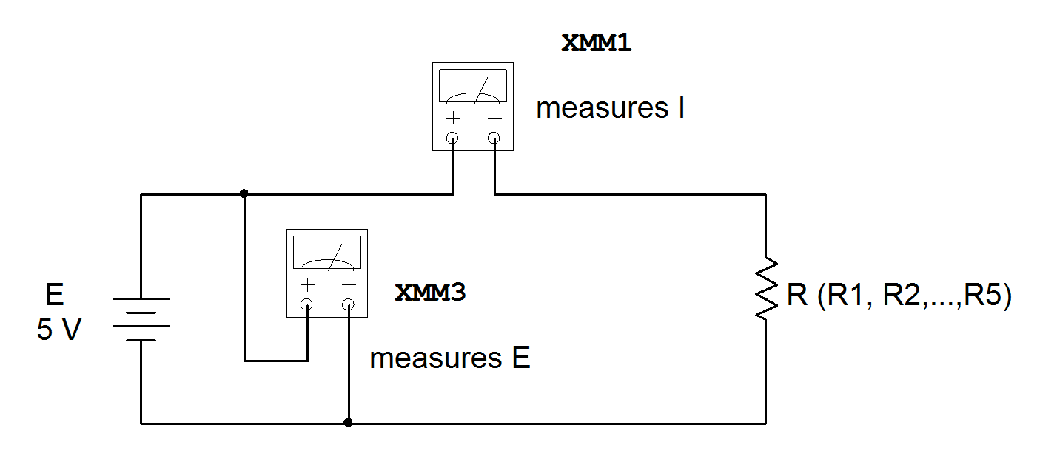

Table 5:

E = 5.047(V)

|  |  |
| --- | --- |
| Resistor | Source Current I (mA) |
| R1 | 10.029 |
| R2 | 5.121 |
| R3 | 2.560 |
| R4 | 1.081 |
| R5 | 0.503 |

Current changed as everyone was powering up. Volts doesn’t change the single circuit element got all the voltage.

Plot a graph showing current I (mA) as a function of resistance R (KΩ).

c) Measuring Voltage:

Locate the **variable voltage source** on the DC power supply (0-30V). Set the meter on the Power Supply to read voltage. Make sure that the source voltage starts at 0V.

Build the circuit in Fig. 2 with R2 (2KΩ) and set the DMM for measuring DC current (mA). Increase the source voltage slowly until the DMM reads 1mA, record the corresponding source voltage in Table 6. repeat for other current values:

Figure 2:

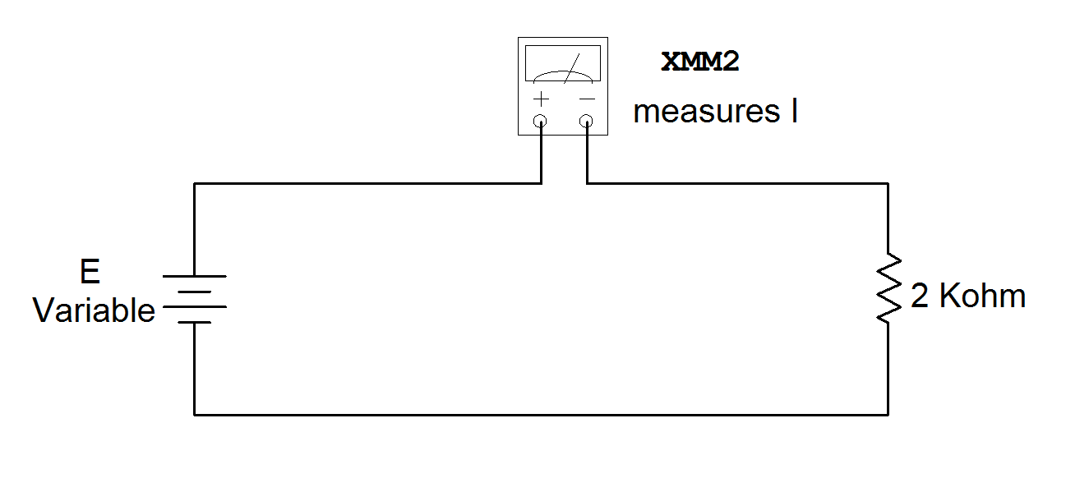

Table 6:

**R = 2KΩ**

**R real = 1.975 k Ω**

|  |  |
| --- | --- |
| Source current I (mA) | Source Voltage V (volt) |
| 1 | 1.9 |
| 2 | 3.9 |
| 3 | 5.9 |
| 4 | 7.8 |
| 5 | 9.8 |

Plot a graph showing voltage E (V) as a function of current I (mA).

**9. LAB REPORT REQUIREMENT:**

Your team’s Lab Report should contain the followings:

**A Cover Page** with Lab Number, Lab Title, Team members’ Names and Date.

**Result Pages** with:

**A - Resistance Measurement:**

Results:

Show a copy of Table 4

Discussions:

1. Are all the results in Table 4 fall within the range of resistance values calculated in Table 1 for 5% tolerance?
2. From the above answer, what can you conclude about the reliability of the resistor manufacturing process?

**B - Current Measurement:**

Results:

Show a copy of Table 5.

Show the plot of I vs. R.

Discussions:

1. Compare the results of Table 2 to those of Table 5; what causes the differences?
2. From the plot, what formula can you use to describe the relationship between I and R?
3. What is the value of the proportionality constant in the above formula? Show your calculation.

**C - Voltage Measurement:**

Results:

Show a copy of Table 6.

Show the plot of E vs. I.

Discussions:

1. Compare the results of Table 3 to those of Table 6; what causes the differences?
2. From the plot, what formula can you use to describe the relationship between E and I?
3. What is the value of the proportionality constant in the above formula? Show your calculation.

**D - Conclusion:** (*it helps to compare your prelab with measured results*)

1. Did the above results demonstrate the validity of Ohm’s Law?

Explain your answer.

2. Are all the Lab objectives met? Explain if some are not.

**Appendix:** Attach all **Pre-Lab calculations** at the end of the Report.